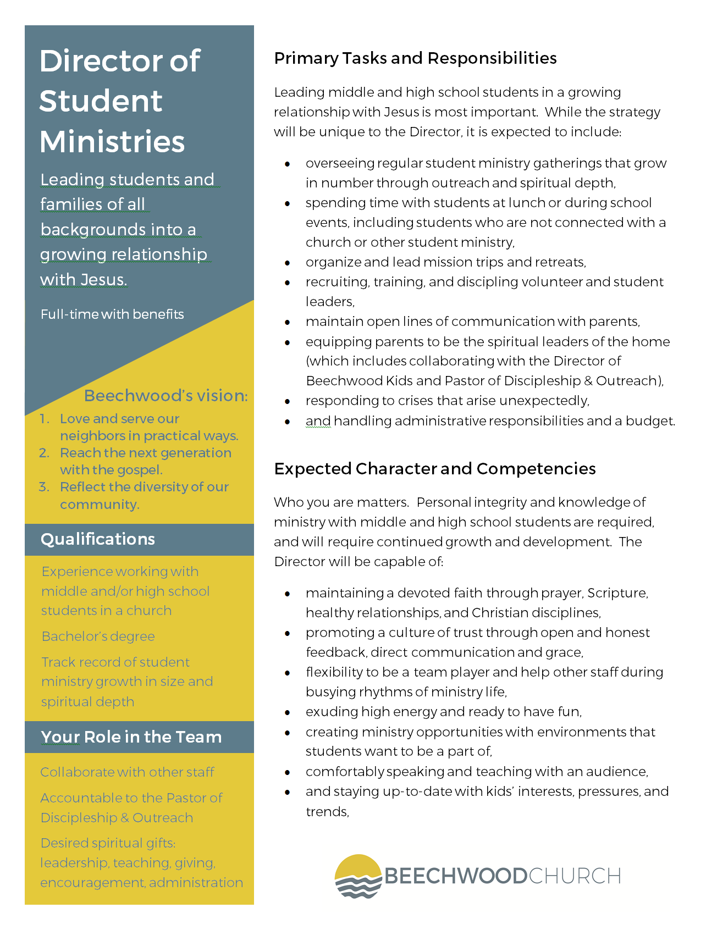
It’s hard to know a person well through just a résumé and cover letter. To help us understand your faith story and approach to ministry a little better, answer each of the three questions below honestly and as straight forward as you can in 400 words or less. When you’re finished, email this document with your résumé and cover letter to searchteam@beechwoodchurch.org.

Tell us about your call to faith and student ministry.

What is the gospel? What does it mean for you, others, and the world?

What are the merits and shortcomings of an attractional model of student ministries?

